Lanarkshire Movement for Change Gathering: Towards a Stigma Free Lanarkshire
Registration form
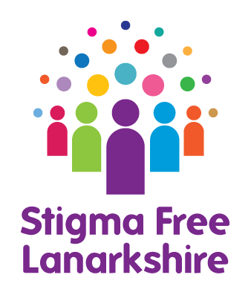

Friday 18th November 2016 Registration 10.00am Start 10.30am Finish 3.00pm
Alona Hotel, Strathclyde Country Park, Motherwell, ML1 3RT

Name
Job title (if applicable)
Organisation (if applicable)
Address
Email
Telephone Number

To help us have a representative gathering, please tell us what best describes you. Tick all that apply.
Work in Health & Social Care in North Lanarkshire |  | Volunteer
Work in Health & Social Care in South Lanarkshire |  | Carer
Employer |  | Work in a voluntary organisation
Lived experience of mental health problems |  | Living in North Lanarkshire
 |  | Living in South Lanarkshire
Other (please specify)

Please specify any dietary or any other requirements you may need

Closing date for registering your interest is Wednesday 9th November. We will confirm your place by Friday 11th November. Please download form and email or post to:
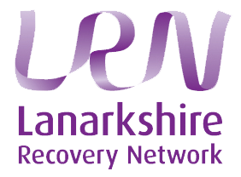
Avril Cutler at Avril.LRN@lanarkshirelinks.org.uk
Lanarkshire Links, Rooms 3.5-3.6, Dalziel Business Centre
7 Scott Street, Motherwell, ML1 1PN
Telephone: 01698 265232

