



**Patient Information Sheet**

**Space in Coronary Heart Disease from Depression & Anxiety**

**What is SilverCloud?**

SilverCloud provides private and secure access anywhere, anytime, to evidence-based, online programs that will help teach you techniques to reduce symptoms of stress, anxiety, low mood, or depression. Based on cognitive behavioural therapy, mindfulness, and positive psychology, SilverCloud is very interactive and very flexible. It can be used on your phone or tablet device so that you always have access to it.

**How will it help me?**

SilverCloud will help you to pinpoint and change unhelpful ways of thinking that can affect how you feel, while teaching you more effective ways of solving problems.

**What is CBT?**

CBT is a psychological therapy that works on the relationships between thoughts (cognitions), behaviours, and feelings. CBT teaches the individual how to recognise and tackle problems here and now, rather than in the past. It has been widely studied and has been proven to work especially on depression and anxiety.

**How to use Silver Cloud?**

We recommended that you spend around 40 minutes per week, over 6 to 8 weeks on SilverCloud, at a regular time if possible. This could be done all at once or broken down into 10-15 minutes, 3 or 4 times a week when you have time to yourself. For example on your lunch breaks, on the bus home, in the evening, when the kids are in bed. As with most things, it may take time and practice to make progress.

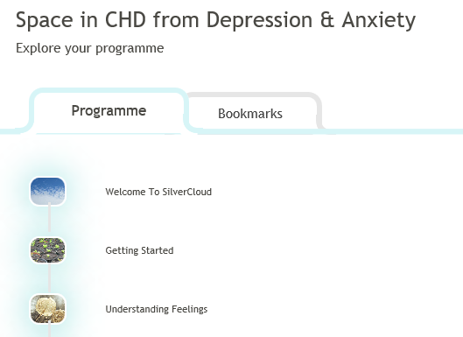**Why Use it?**

SilverCloud programs have demonstrated a high improvement rates for stress, anxiety and depression. You set your own pace, it is not time consuming, and you don’t have to stick to rigid appointments.





**How do I access Silver Cloud?**



To access the program you will need to be referred by a doctor or nurse at your GP Practice or another Medical Professional.

You will then receive an email from the CCBT Coordinator containing a link to activate your account.

**Where can I complete the program?**

The course can be completed in your home or in a community site such as a library. Using either a desktop computer, laptop, tablet or Smartphone.

**Is the information I put in confidential?**

Yes. You have a username and password so that no-one else can access the details you enter and all your data is stored in an encrypted database. Sometimes data that is routinely collected during the course of the treatment will be used in service improvement and evaluation. The information may be shared with other Health Boards or nationally with NHS 24. This information is always anonymised. This means all information which could be used to identify you is removed and your confidentiality is maintained.

**What are Reviews?**

Every 4 to 5 weeks during your online treatment you will be asked to take part in a “Review” on an agreed review date. During a review you will be asked to complete questionnaires and share any comments that you have made over the course of completing the SilverCloud modules. The cCBT service will then provide written feedback and additional advice that will appear on your Homepage and the Messages page. The feedback and advice provided will not be clinical in nature. If you need clinical support at any stage throughout the online treatment please contact your referring clinician to discuss this.

**Reporting suicidal thoughts**

During a review you will be asked if you have had thoughts of harming yourself. If you answer that you have, your cCBT co-ordinator will inform the person that referred you to the programme. If you are completing the course outside of standard working hours it is recommended you contact NHS 24 to discuss these feelings. The cCBT coordinator will then inform your referrer in the morning of the next working day.

**Space in CHD from Depression & Anxiety – Core Modules**

**Welcome To SilverCloud-** This short module introduces you to the programme.

**Getting Started -** This module shows you the basics of Cognitive Behavioural Therapy (or CBT) for CHD, and introduces some of the key ideas of the programme

**Understanding Feelings -** This module takes a closer look at moods and emotions. In this module you can explore different aspects of emotions, physical reactions, action and inaction, and see how they are all connected.

**Boosting Behaviour -** This module looks at how doing things a little differently can be a really great way to start to lift your mood.

**Spotting Thoughts -** This module looks at the impact of unhelpful automatic thinking on your mood. It also helps you to tune in to your thoughts and to recognise any common thinking errors.

**Challenging Thoughts -** This module takes the next step in helping you tackle distorted or overly negative thinking patterns which can impact your mood.

**Managing Worry -** This module introduces you to the role of worry in anxiety. You will learn how to cope with and manage your worry more effectively.

**Facing your Fears-** This module will help you to break your fears down so that you can start to face them, and also reduce your anxiety.

**Core Beliefs -** This module shows the role that deeply-held core beliefs can play in mood.

**Bringing It All Together -** In this final module you can bring together all the skills you have learned, and the ideas you have gathered so far.

Additional Modules

**Challenging Times- T**he scale of the COVID-19 crisis is disrupting our personal and working lives. This module aims to support you in finding helpful ways to cope and adjust to these extraordinary circumstances.

**My Self-Esteem and I -** This module is about an often ignored relationship: the one we have with ourselves. This involves our beliefs about ourselves and how we tend to act towards ourselves.

**Sleep Difficulties -** This module takes a closer look at sleep and helps you to understand your difficulties with sleep.

**Relaxation -** This module introduces you to some relaxation techniques that you can use in your day-to-day life.

**Employment Support -** This module takes a look at some of the difficulties you may encounter in work, or when returning to work after a period of unemployment.

**Behavioural Experiments -** In this module, you will learn how to test your negative thoughts and predictions.

**Anger Management -** This module will help you to gain a better understanding of your anger. You will learn to how to manage your anger more effectively.

**Communication & Relationships -** This module focuses on the way we communicate and relate to people in our lives. It looks at what we can do to make our relationships satisfying.

**Grief & Loss -** This module explores the experience of loss and helps you to understand your own unique grieving process.