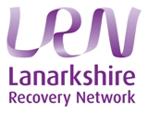
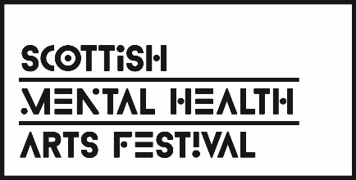

Lanarkshire Funding Proposal Form 2022

After the success of previous festival campaigns, Lanarkshire is delighted to announce their participation in the 16th Scottish Mental Health Arts Festival. This year’s theme is ‘GATHER’ & will be running from 4th- 24th May 2022. The aim of the festival is to promote positive attitudes towards mental health, mental illness, support and recovery, and to effect significant cultural change through the insights and influences of the creative arts. The festival fundamentally seeks to strengthen the links between arts, community and public organisations.

Festival Aims

The festival is part of a wider programme of mental health improvement, which aims to:
- Promote positive attitudes around mental health problems.
- Increase understanding of mental health and well-being – and how we can promote and support our own and others mental health and well-being.
- Increase awareness of what help and support is available.

As well as the above objectives the festival also wishes to:
- Increase awareness of the important part that the arts can play in supporting and promoting mental health and well-being.
- To engage with the local media to support mental health awareness.
- To increase participation by varying the opportunities to engage by using different mediums, targeting different age spans, spreading across Lanarkshire and creatively promoting the events.
- To link with existing arts and cultural programmes to showcase sustainable projects and build mental health awareness into existing projects and programmes.
- To strengthen the links between arts, community, academic, voluntary and public organisations.
- To challenge and engage on the topics of stigma, recovery and mental health inequalities.

In light of Covid-19 & the changing landscape, proposals for physical & virtual events will be accepted. If you are planning a physical event please consider a contingency plan if restrictions won’t allow for a physical event to go ahead.

Project Description
Please describe the nature of the project?
Project Objective:
What is the project trying to achieve?

Project Genre:
Film Theatre Multi Arts
Dance Comedy Workshops
Music Words
Visual Arts Other

Support
What support, if any, would you require from the Lanarkshire Festival Team?

Media Strategy
How do you plan to advertise your event?

Funding
Please state how much funding is being requested and a breakdown of how this will be spent (maximum £500)?

Name of person completing application

Please return this form by Friday 4th February 2022 to:
susan.mcmorrin@lanarkshire.scot.nhs.uk

