
BRIEFING 2 – Primary & Community Care, & Voluntary and Community Organisations

On behalf of the Lanarkshire Healthy Reading Programme Steering Group, I am writing to give you advanced notice of the launch of the Healthy Reading Programme on the 28th January 2010. The success of this programme will depend greatly on colleagues across agencies using it for the benefit of their clients. With this mind I would like to tell you briefly about this programme in preparation for launch. For further information please e-mail fiona.ingram@lanarkshire.scot.nhs.uk

Kevin O’Neill, Chair of the Lanarkshire Healthy Reading Programme Steering Group

HEALTHY READING IN ALL 50 LIBRARIES ACROSS LANARKSHIRE

The Healthy Reading Programme has been developed in partnership with NHS Lanarkshire, North and South Lanarkshire Councils and the Lanarkshire Recovery Network to make it easier to get mental health and well-being leaflets, books, CDs, DVDs and web-based support. All 50 libraries across Lanarkshire have resources which are aimed at helping people get the most from life such as becoming more assertive, sleeping better and confident or helping people overcome and cope with mental health problems such as depression, eating disorder, bereavement, dementia, panic and much more. There are also resources for all ages including supporting positive parenting, young people, adults and older people. This programme has been developed because the evidence shows that “biblio-therapy” has an important part to play in increasing the availability of support, information and self-help for improving mental health and well-being. The programme will be supported via elament www.lanarkshirementalhealth.org.uk where you find a full list of libraries and all resources that can be accessed, which will be established prior to launch. Library staff have participated in mental health awareness training in preparation and will provide a warm and friendly welcome and atmosphere, assist people to find the resources that they are looking for and assist people to access a computer if they are wishing to use any of the on-line self-help resources. Resources will be provided in other formats on request.

LANARKSHIRE’S MENTAL HEALTH & WELL-BEING ON-LINE RESOURCES ‘elament’

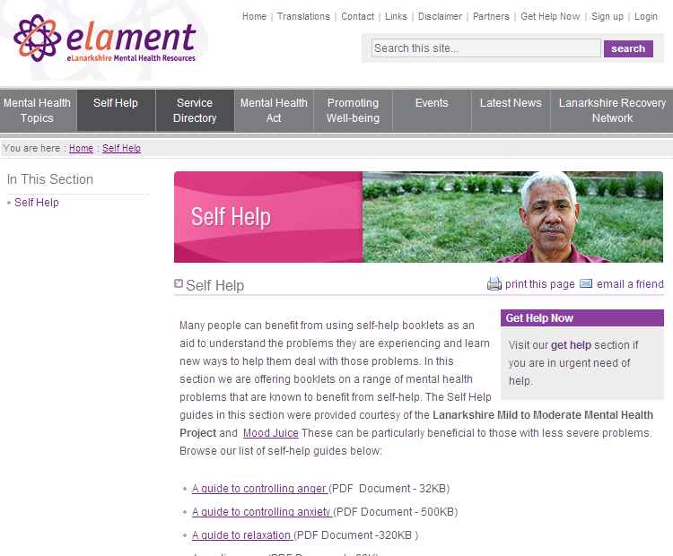
As part of the programme Lanarkshire’s Mental Health and Well-being Website will also be re-launched, with a series of 15 of self-help leaflets which can be printed by the public or service providers on behalf of their clients. The website will also include an improved service directory with maps built in to help people access services more easily. www.lanarkshirementalhealth.org.uk

MIND TO LISTEN: AN AUDIO CD TO SUPPORT MENTAL HEALTH & WELL-BEING THROUGH SELF-HELP
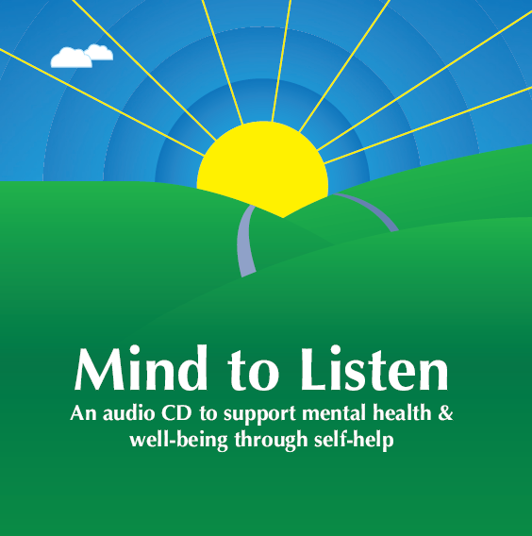
Increasingly people are listening to talking books. We also know that many people have difficulty with reading. We also understand that a number of people who have moved to Lanarkshire can understand spoken english but not written english. With this in mind a CD with a self-help insert booklet has been produced in Lanarkshire with advice on how to stay mentally healthy, overcome and cope with stress, low mood, bereavement, sleep and includes relaxation exercises. This will launch on 28th January 2010 and will be available from every library or can be downloaded from ‘elament’ website www.lanarkshirementalhealth.org.uk “
SELF-HELP RESOURCES THAT YOU CAN ORDER

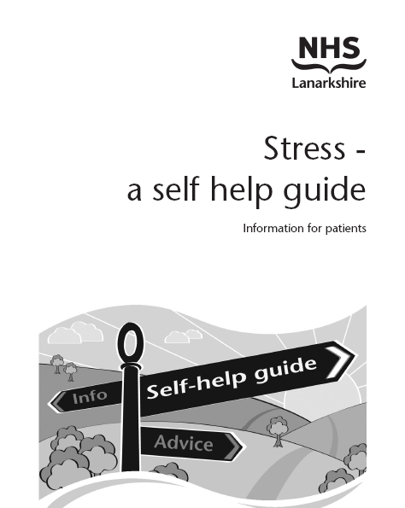
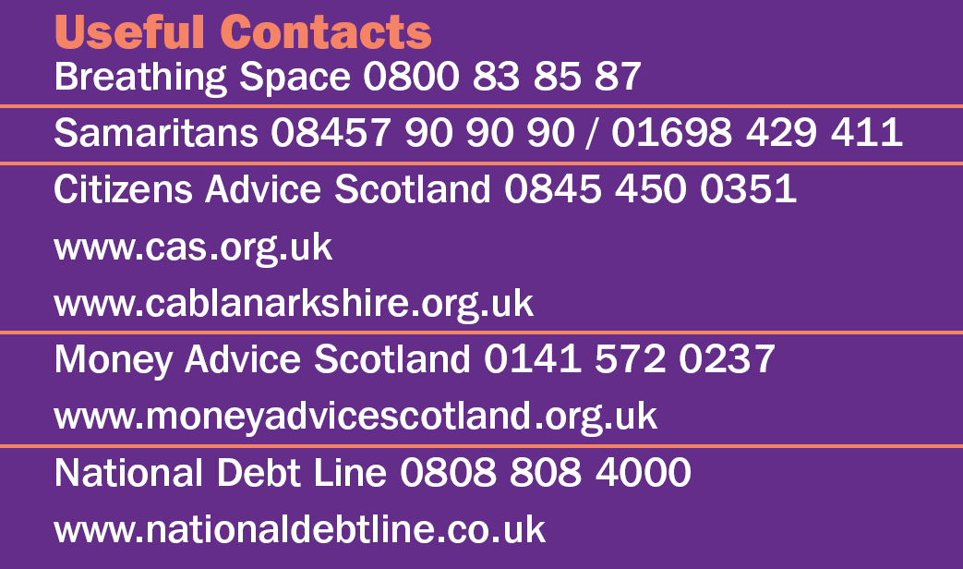
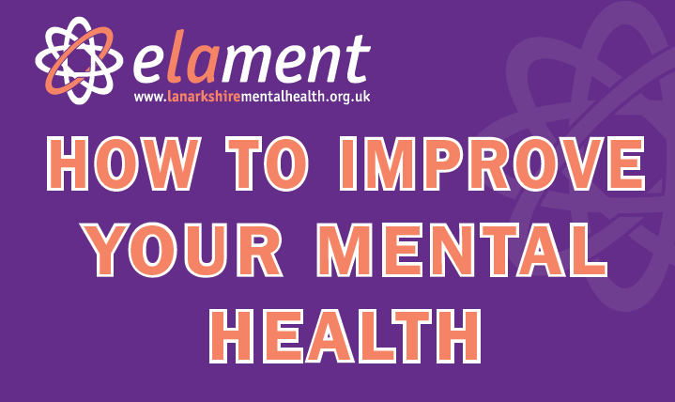
A range of resources have been published for you to hand to clients at the point of contact.
These can be ordered by e-mailing fiona.ingram@lanarkshire.scot.nhs.uk.
Stress and depression are the most common mental health problems, we have published hard copies of these self-help leaflets for distribution. Thirteen other topics can been down loaded from elament as required. A double sided wallet card promoting elament and telephone support and a concertina card providing 10 tips to staying mentally healthy has also been produced.

HEALTHY READING PATHWAY

The following pathway has been produced to support the delivery of healthy reading:
www.lanarkshirementalhealth.org.uk

