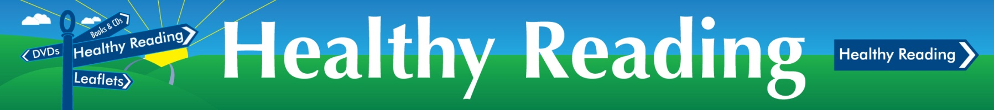
Resource Recommendation Form
Lanarkshire’s Healthy Reading Programme was developed to make it easier to access mental health and well-being leaflets, books, CDs, DVDs and web-based support. All Lanarkshire libraries have resources which are aimed at helping people get the most from life such as living life to the full, sleeping better and becoming more confidence and assertive. Healthy reading can be helpful for people to overcome and cope with mental health problems such as anxiety, depression, stress, dementia and panic. There are also resources for all ages including supporting young people, adults and older people as well as items on positive parenting.

If you would like to recommend a resource (book, DVD, CD) to be part of the Lanarkshire Healthy Reading Programme, please complete this form and return to LRN@lanarkshirelinks.org.uk

Resource Type: Book DVD CD
Other (please specify):

Resource Details:
Author/Editor:
Title:
Publisher: (if known)
Date or edition: (if known)
ISBN: (if known)
Please include any comments or further details on why you think this resource should be included as part of the Healthy Reading Programme.

Your Details:
Name
Email address

