

**Patient Information Sheet**

**What is SilverCloud?**

SilverCloud provides private and secure access anywhere, anytime to evidence-based, online programs that will help to teach you techniques that helps you reduce symptoms of stress, anxiety, low mood or depression. Based on cognitive behavioural therapy, mindfulness and positive psychology SilverCloud is very interactive and very flexible. The program can be run on a PC or laptop. It can also be used on your mobile phone or tablet device so that you always have access to it.

**How will it help me?**

SilverCloud will help you to pinpoint and change unhelpful ways of thinking that can affect how you feel while teaching you more effective ways of solving problems.

**What is CBT?**

CBT is a psychological therapy that works on the relationships between thoughts (cognitions), behaviours and feelings. CBT teaches the individual how to recognise and tackle problems here and now, rather than in the past. It has been widely studied and has been proven to work especially on depression and anxiety.

**How to use Silver Cloud?**

We recommended use SilverCloud 40 minutes per week, over 6-8 weeks at a regular time if you can about 3 or 4 times a week about 10-15 minutes when you have time to yourself for example on your lunch breaks, on the bus home, in the evening, when the kids are in bed. As with most things, it may take time and practice to make progress.

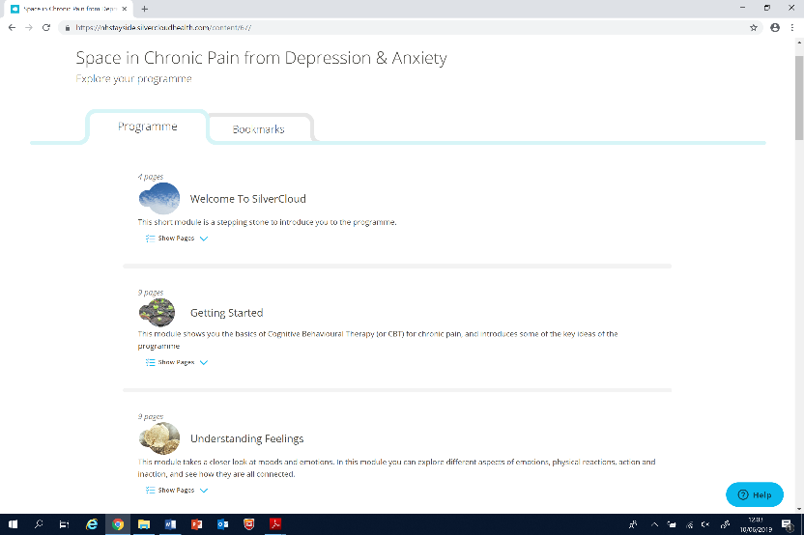**Why Use it?**

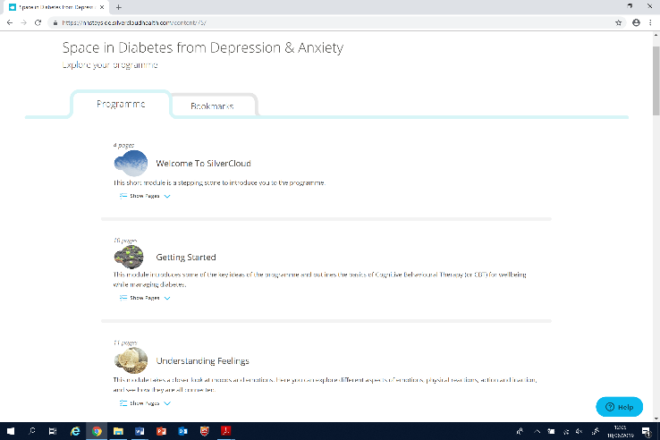SilverCloud programs have demonstrated high improvement rates for stress, anxiety and depression. You set your own pace, it is not time consuming, and you don’t have to stick to rigid appointments.

**How do I access Silver Cloud?**

You will or may have already received sign-up instructions from your local cCBT service. This may be an email, letter, text message or by phone.

In these instruction simply, use the link to access the Silver Cloud program. Then create a secure username and password, read the support agreement and complete the questionnaires. After these steps you able be able to get started with SilverCloud.

**Where can I complete the program?**

The course can be completed in your home or in a community site such as a library using either a desktop computer, laptop, tablet or Smartphone.

**Is the information I put in confidential?**

Yes. You have a username and password so that no-one else can access the details you enter and all your data is stored in an encrypted database. Sometimes data that is routinely collected during the course of the treatment will be used in service improvement and evaluation. The information maybe shared with other Health Boards, nationally with NHS 24. This information is always anonymised, this means all information that could be used to identify you is removed and your confidentiality is maintained.

**What are Reviews?**

Every 4 to 5 weeks during your online treatment you will be asked to take part in a “review” on an agreed review date. During a review will be asked to complete questionnaires and share any comments that you have made over the course of completing the SilverCloud modules. The cCBT service will then provide written feedback and additional advice through that will appear on your Homepage and the Messages page. The feedback and advice provided will not be clinical in nature. If you need clinical support at any stage throughout the online treatment please contact your referring clinician to discuss your concerns.

**Reporting suicidal thoughts**

During a review you will be asked if you have had thoughts of harming yourself. If you answer that you have, your cCBT co-ordinator will inform the person that referred you to the programme. If you are completing the course outside of standard working hours it is recommended you contact NHS 24 to discuss these feelings. The cCBT coordinator will then inform your referrer in the morning of the next working day.

**Space in Chronic Pain from Depression & Anxiety -** **SilverCloud Modules**

**Core Modules**

**Welcome To SilverCloud -** This short module is a stepping stone to introduce you to the programme.

**Getting Started -** This module shows you the basics of Cognitive Behavioural Therapy (or CBT) for chronic pain, and introduces some of the key ideas of the programme

**Understanding Feelings -** This module takes a closer look at moods and emotions. In this module you can explore different aspects of emotions, physical reactions, action and inaction, and see how they are all connected.

**Boosting Behaviour -** This module looks at how doing things a little differently can be a really great way to start to lift your mood.

**Spotting Thoughts -** This module looks at the impact of unhelpful automatic thinking on your mood. It also helps you to tune in to your thoughts and to recognise any common thinking errors.

**Challenging Thoughts -** This module takes the next step in helping you tackle distorted or overly negative thinking patterns which can impact your mood.

**Managing Worry -** This module introduces you to the role of worry in anxiety. You will learn how to cope with and manage your worry more effectively.

**Anxiety & Your Health -** In this module, you can explore the unhelpful behaviours that are common in health anxiety and learn to identify and manage these behaviours.

**Core Beliefs -** This module shows the role that deeply-held core beliefs can play in mood.

**Bringing It All Together -** In this final module you can bring together all the skills you have learned, and the ideas you have gathered so far.

Additional Modules - optional

**My Self-Esteem and I -** This module is about an often ignored relationship: the one we have with ourselves. This involves our beliefs about ourselves and how we tend to act towards ourselves.

**Sleep Difficulties -** This module takes a closer look at sleep and helps you to understand your difficulties with sleep.

**Relaxation -** This module introduces you to some relaxation techniques that you can use in your day-to-day life.

**Employment Support -** This module takes a look at some of the difficulties you may encounter in work, or when returning to work after a period of unemployment.

**Behavioural Experiments -** In this module, you will learn how to test your negative thoughts and predictions.

**Anger Management -** This module will help you to gain a better understanding of your anger. You will learn to how to manage your anger more effectively.

**Communication & Relationships -** This module focuses on the way we communicate and relate to people in our lives. It looks at what we can do to make our relationships satisfying.

**Grief & Loss -** This module explores the experience of loss and helps you to understand your own unique grieving process.